FlyAway ScreenShots

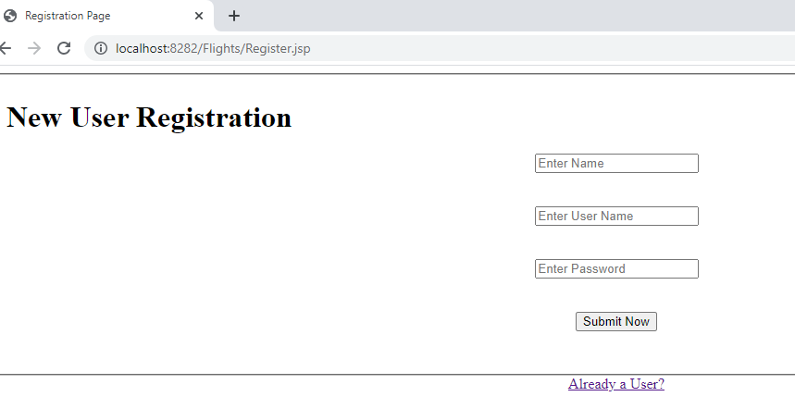

Fig(1) User Registration form

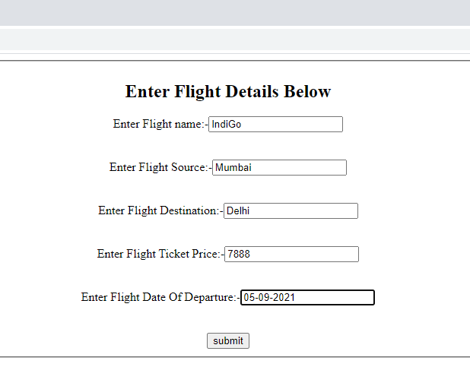

Fig(2)Admin Enters Details Of Flights

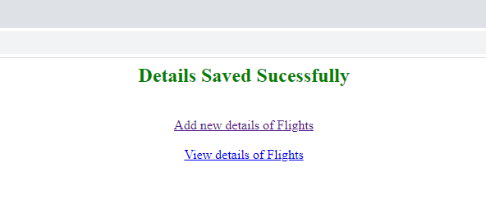

Fig(3)Output of Flight Servlet

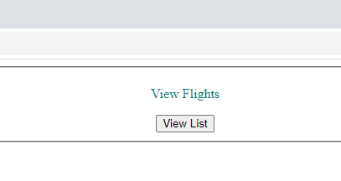

Fig(5)View List Of Flights

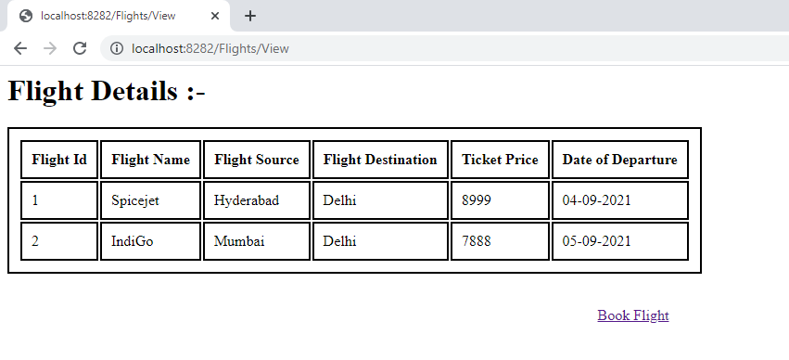

Fig(6)Details of Flights

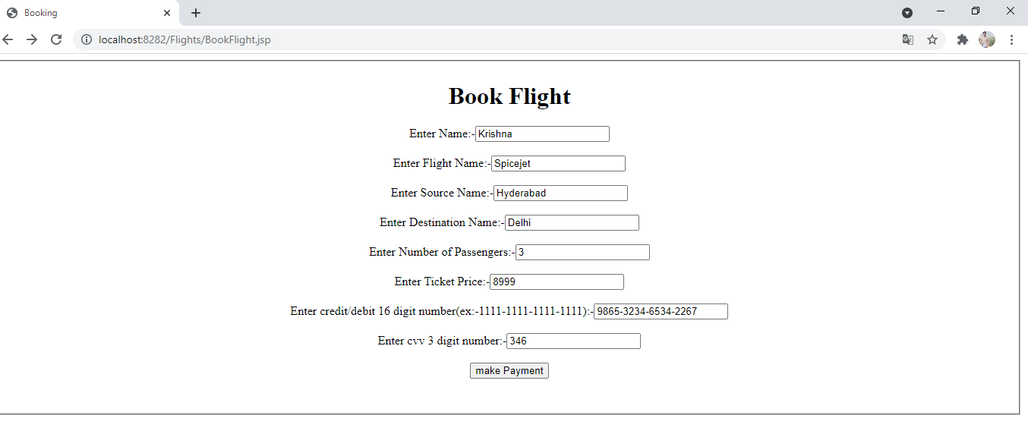

Fig(7)Flight Booking

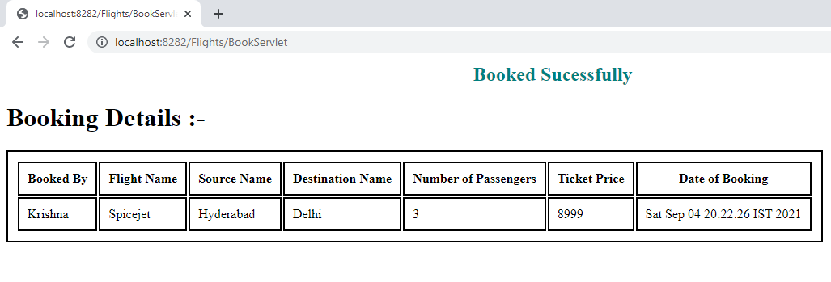

Fig(8)Booking Sucess